Daily Fact Sheets for Asia #___ Name: ___________________
Why is this important? _______________________________________________ Date: ________ Per: _______

Learning Target: ________________________________________________________________________________
I can: __________________________________________________________________________________________

World’s Population is: ____________________

PARTS OF THE GLOBE:
__ __ __ __ 7 continents ______________________________________________________________
__ __ __ __ 4 oceans ______________________________________________________________
__ __ __ __ Continent ______________________________________________________________
__ __ __ __ Ocean ______________________________________________________________
__ __ __ __ Globe ______________________________________________________________
__ __ __ __ Hemisphere ______________________________________________________________
__ __ __ __ Antarctic Circle ______________________________________________________________
__ __ __ __ Arctic Circle ______________________________________________________________
__ __ __ __ Tropic of Cancer ______________________________________________________________
__ __ __ __ Tropic of Capricorn ______________________________________________________________
__ __ __ __ Equator ______________________________________________________________
__ __ __ __ Prime Meridian ______________________________________________________________
__ __ __ __ Compass rose _______________________________________________________________
__ __ __ __ Cardinal directions _______________________________________________________________
__ __ __ __ legend or key _______________________________________________________________
__ __ __ __ scale _______________________________________________________________

Daily Fact Sheets for Asia #___ Name: ___________________
Why is this important? _______________________________________________ Date: ________ Per: _______

Learning Target: ________________________________________________________________________________
I can: __________________________________________________________________________________________

PLATE TECTONICS:
__ __ __ __ plate tectonics _____________________________________________________________
__ __ __ __ Wegner _____________________________________________________________
__ __ __ __ Pangaea _____________________________________________________________
__ __ __ __ Gondwana _____________________________________________________________
__ __ __ __ Laurasia _____________________________________________________________
__ __ __ __ Panthalassa _____________________________________________________________
__ __ __ __ ring of fire _____________________________________________________________
__ __ __ __ Marianas Trench _____________________________________________________________

TYPES OF GEOGRAPHY:
__ __ __ __ Cultural geography _____________________________________________________________
__ __ __ __ Culture _____________________________________________________________
__ __ __ __ Heterogeneous (w/ ex.) _____________________________________________________________
__ __ __ __ Homogeneous (w/ ex.) _____________________________________________________________
__ __ __ __ Physical Geography _____________________________________________________________

UNDERSTANDING LATITUDE/LONGITUDE:
__ __ __ __ Latitude ______________________________________________________________
__ __ __ __ Longitude ______________________________________________________________
__ __ __ __ Parallels ______________________________________________________________
__ __ __ __ Meridians ______________________________________________________________
__ __ __ __ IDL ______________________________________________________________
__ __ __ __ North Pole ______________________________________________________________
__ __ __ __ South Pole ______________________________________________________________
__ __ __ __ 90 ______________________________________________________________
__ __ __ __ 180 ______________________________________________________________
__ __ __ __ 0 ______________________________________________________________
__ __ __ __ degrees ______________________________________________________________

__ __ __ __ High Latitudes ______________________________________________________________
__ __ __ __ Mid Latitudes ______________________________________________________________
__ __ __ __ Low Latitudes ______________________________________________________________
__ __ __ __ Polar ______________________________________________________________
__ __ __ __ Temperate ______________________________________________________________
__ __ __ __ Tropical ______________________________________________________________

Daily Fact Sheets for Asia #___ Name: ___________________
Why is this important? _______________________________________________ Date: ________ Per: _______

Learning Target: ________________________________________________________________________________
I can: __________________________________________________________________________________________

Fact Sheet on Asia

___ ___ ___ ___ Asia _________________________________________________________
___ ___ ___ ___ 3 largest countries in size _________________________________________________________
___ ___ ___ ___ 3 most populated countries _________________________________________________________
___ ___ ___ ___ 3 largest lakes in the world _________________________________________________________

REGIONS OF ASIA:
___ ___ ___ ___ East Asia ________________________________________________________
___ ___ ___ ___ Central Asia ________________________________________________________
___ ___ ___ ___ Indochina Peninsula ________________________________________________________
___ ___ ___ ___ Middle East/West Asia _________________________________________________________
___ ___ ___ ___ Siberia ________________________________________________________
___ ___ ___ ___ Steppe ________________________________________________________
___ ___ ___ ___ Permafrost _________________________________________________________
___ ___ ___ ___ Methane Leeching _________________________________________________________
___ ___ ___ ___ Drunken Trees _________________________________________________________
___ ___ ___ ___ South Asia ________________________________________________________
___ ___ ___ ___ subcontinent ________________________________________________________

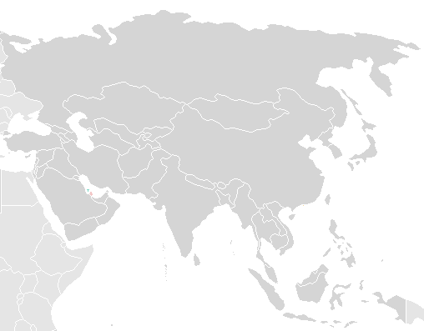

MOUNTAIN RANGES:
___ ___ ___ ___ Himalaya ________________________________________________________
___ ___ ___ ___ Mount Everest ________________________________________________________
___ ___ ___ ___ Hillary/Tenzing ________________________________________________________
___ ___ ___ ___ Sherpas ________________________________________________________
___ ___ ___ ___ K2 ________________________________________________________
___ ___ ___ ___ Mount Ararat ________________________________________________________
___ ___ ___ ___ Mount Fuji ________________________________________________________
___ ___ ___ ___ Ural ________________________________________________________
___ ___ ___ ___ Taurus ________________________________________________________
___ ___ ___ ___ Zagros ________________________________________________________
___ ___ ___ ___ Hindu Kush ________________________________________________________
___ ___ ___ ___ Khyber Pass ________________________________________________________
___ ___ ___ ___ E/W Ghats ________________________________________________________
___ ___ ___ ___ Rain Shadow Effect _________________________________________________________
___ ___ ___ ___ monsoon ________________________________________________________
___ ___ ___ ___ Warm ocean current ________________________________________________________
___ ___ ___ ___ Cool ocean Current ________________________________________________________
___ ___ ___ ___ Caucasus _________________________________________________________
___ ___ ___ ___ Terracing ________________________________________________________

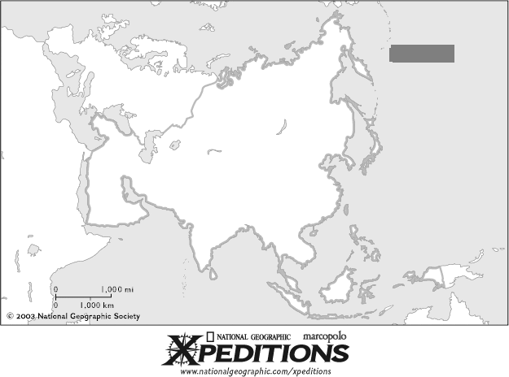

MAJOR RIVERS:
___ ___ ___ ___ Yangtze ________________________________________________________
___ ___ ___ ___ 3 Gorges Dam ________________________________________________________
___ ___ ___ ___ Yellow/Huang He ________________________________________________________
___ ___ ___ ___ loess ________________________________________________________
___ ___ ___ ___ Mekong ________________________________________________________
___ ___ ___ ___ Tigris/Euphrates ________________________________________________________
___ ___ ___ ___ Ganges ________________________________________________________
___ ___ ___ ___ Brahmaputra ________________________________________________________
___ ___ ___ ___ Indus ________________________________________________________
SURROUNDING & MAJOR INTERNAL WATER BODIES:
___ ___ ___ ___ Arabian Sea ________________________________________________________
___ ___ ___ ___ Bay of Bengal ________________________________________________________
___ ___ ___ ___ Sea of Japan _________________________________________________________
___ ___ ___ ___ Bering Strait _________________________________________________________
___ ___ ___ ___ Dead Sea ________________________________________________________
___ ___ ___ ___ Caspian Sea ________________________________________________________
___ ___ ___ ___ Aral Sea ________________________________________________________
___ ___ ___ ___ Lake Baikal ________________________________________________________
___ ___ ___ ___ Jog Falls _________________________________________________________
___ ___ ___ ___ Sea of Japan ________________________________________________________

MAJOR DESERTS:
___ ___ ___ ___ Thar ________________________________________________________
___ ___ ___ ___ Gobi ________________________________________________________

COUNTRIES/TERRITORIES & CITIES:
___ ___ ___ ___ Bangladesh ________________________________________________________
___ ___ ___ ___ Nepal _________________________________________________________
___ ___ ___ ___ Sri Lanka _________________________________________________________
___ ___ ___ ___ Vietnam _________________________________________________________
___ ___ ___ ___ Kashmir ________________________________________________________
___ ___ ___ ___ Kathmandu ________________________________________________________
___ ___ ___ ___ Bhutan ________________________________________________________
___ ___ ___ ___ Indonesia ________________________________________________________
___ ___ ___ ___ Taiwan ________________________________________________________
___ ___ ___ ___ Moscow ________________________________________________________
___ ___ ___ ___ Jerusalem ________________________________________________________
___ ___ ___ ___ New Delhi ________________________________________________________
___ ___ ___ ___ Tokyo ________________________________________________________
___ ___ ___ ___ Tehran _________________________________________________________
___ ___ ___ ___ Seoul _________________________________________________________
___ ___ ___ ___ Pyongyang _________________________________________________________
___ ___ ___ ___ Islamabad _________________________________________________________
___ ___ ___ ___ Kabul _________________________________________________________
___ ___ ___ ___ Mecca ________________________________________________________
___ ___ ___ ___ Beijing ________________________________________________________
___ ___ ___ ___ Skull Island ________________________________________________________
___ ___ ___ ___ Japan ________________________________________________________
___ ___ ___ ___ Honshu ________________________________________________________
Daily Fact Sheets for Europe #___ Name: ___________________
Why is this important? _______________________________________________ Date: ________ Per: _______

Learning Target: ________________________________________________________________________________
I can: __________________________________________________________________________________________

World’s Population is: ____________________

___ ___ ___ ___ Vatican City _______________________________________________________________
___ ___ ___ ___ European Union _______________________________________________________________
___ ___ ___ ___ North Sea _______________________________________________________________
___ ___ ___ ___ Ural Mts. _______________________________________________________________
___ ___ ___ ___ Mediterranean _______________________________________________________________
___ ___ ___ ___ Strait of Gibraltar _______________________________________________________________
___ ___ ___ ___ region _______________________________________________________________
___ ___ ___ ___ peninsula _______________________________________________________________
___ ___ ___ ___ Stonehenge _______________________________________________________________
___ ___ ___ ___ Hadrian’s Wall _______________________________________________________________
___ ___ ___ ___ Great Britain _______________________________________________________________
___ ___ ___ ___ London _______________________________________________________________
___ ___ ___ ___ Paris _______________________________________________________________
___ ___ ___ ___ Athens _______________________________________________________________
___ ___ ___ ___ Madrid _______________________________________________________________
___ ___ ___ ___ Iberian Peninsula _______________________________________________________________
___ ___ ___ ___ Moscow _______________________________________________________________
___ ___ ___ ___ Rome _______________________________________________________________
___ ___ ___ ___ Berlin _______________________________________________________________
___ ___ ___ ___ Istanbul _______________________________________________________________
___ ___ ___ ___ Bosporus Strait _______________________________________________________________
___ ___ ___ ___ Black Sea _______________________________________________________________
___ ___ ___ ___ Caucasus _______________________________________________________________
___ ___ ___ ___ Danube River _______________________________________________________________
___ ___ ___ ___ Volga River _______________________________________________________________
___ ___ ___ ___ Alps _______________________________________________________________
___ ___ ___ ___ Blanc _______________________________________________________________
___ ___ ___ ___ Elbrus _______________________________________________________________
___ ___ ___ ___ Pyrenees _______________________________________________________________
___ ___ ___ ___ English Channel _______________________________________________________________
___ ___ ___ ___ Chunnel _______________________________________________________________
___ ___ ___ ___ Acid Rain _______________________________________________________________

